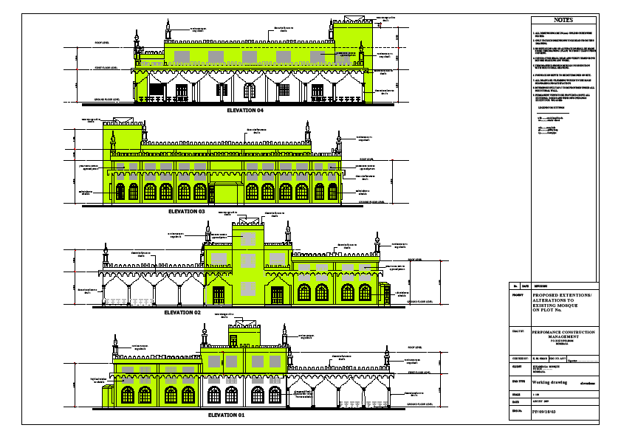
Drawings of extensions for masjid at Majlisul Ma'arif el-Islamiyyah as seen from different sides
New extensions Existing masjid

